输入输出专向训练
（一）
1

#include<stdio.h>
int main()
{
int a,b;
float x,y;
char c1,c2;
scanf("a=%d b=%d",&a,&b);
scanf("%f%e",&x,&y);
scanf("%c%c",&c1,&c2);
printf("a=%d,b=%d,x=%f,y=%f,c1=%c,c2=%c\n",a,b,x,y,c1,c2);
return 0;
}
（1）
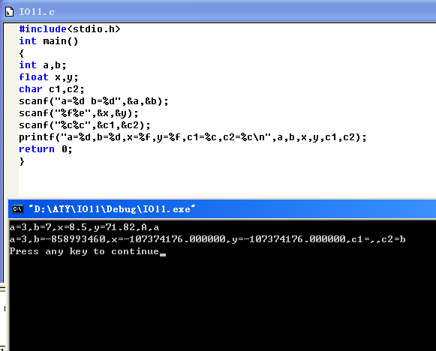
(2)
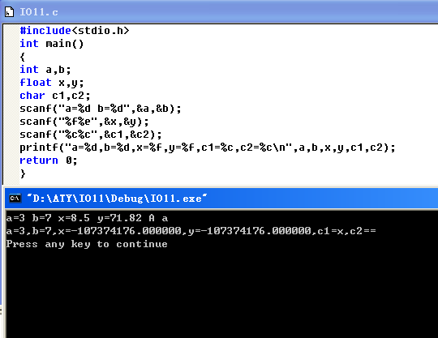
(3)
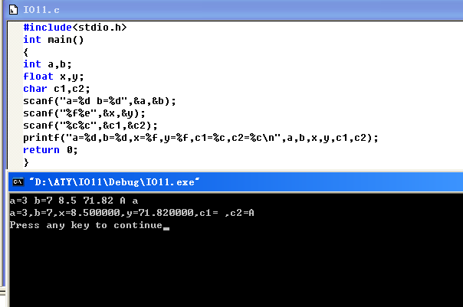
(4)
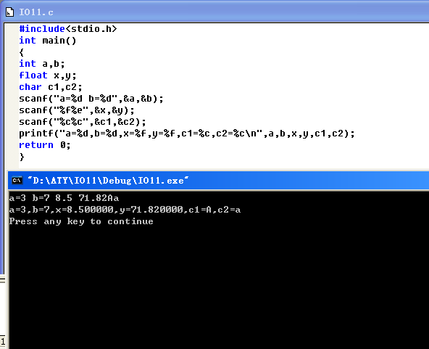
(5)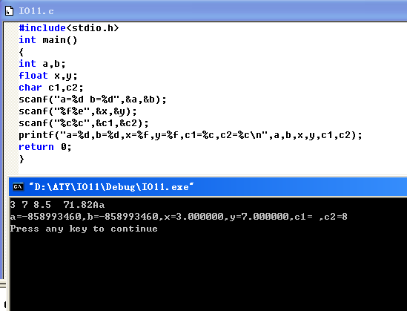
(6)
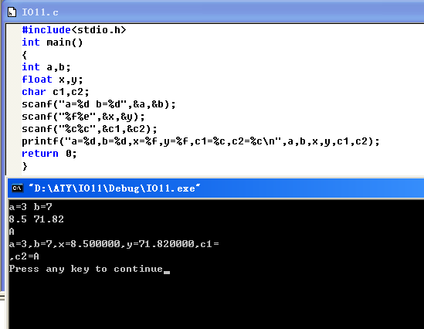
(7)
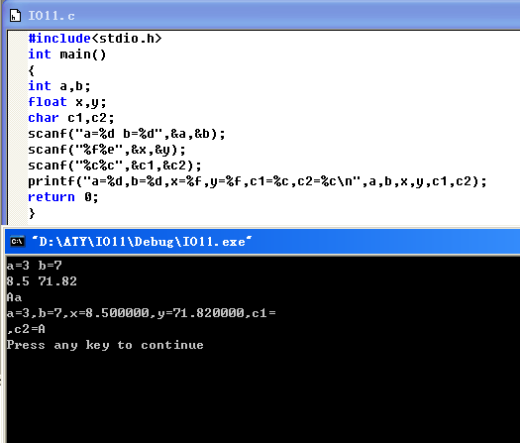
(8)
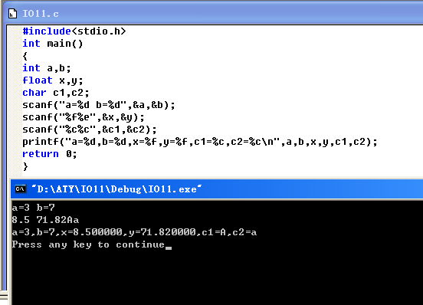
2

#include <stdio.h>
main()
{
int a;
char b;
float c;
printf("Please input an integer:");
scanf("%d",&a);
printf("integer:%d\n",a);
printf("Please input a character:");
scanf("%c",&b);
printf("character:%c\n",b);
printf("Please input a float number:");
scanf("%f",&c);
printf("float:%f\n",c);
}
(1)
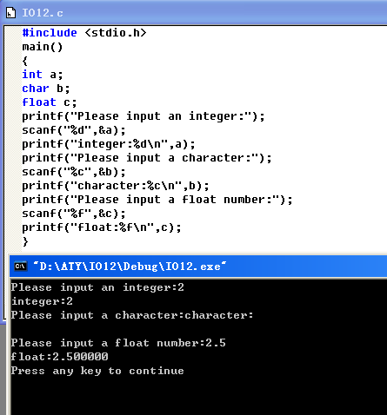
(2)
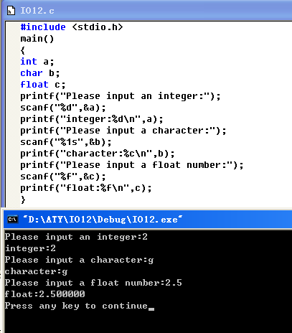
3

#include <stdio.h>
void main()
{
int a,b;
printf("Please input a and b:");
scanf("%2d%*2d%2d",&a,&b);
printf("a=%d,b=%d,a+b=%d\n",a,b,a+b);
}
(1)
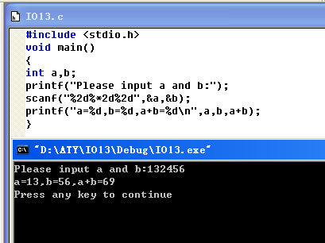
(2)
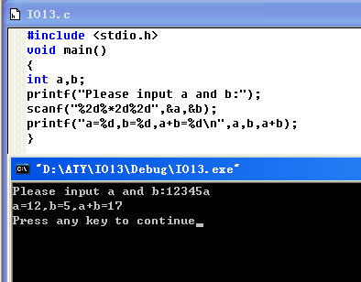
4

#include <stdio.h>
main()
{
int a=-1;
printf("%d, %o, %x",a,a,a);
printf("%8o,%12x",a,a);
}
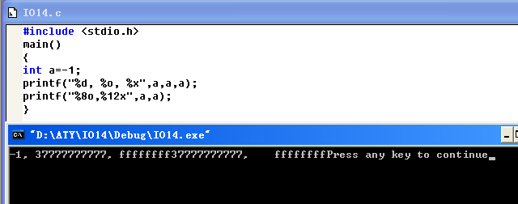
5

#include <stdio.h>
void main()
{
unsigned int a=65535;int b=-2;
printf("a=%d,%o,%x,%u\n",a,a,a,a);
printf("b=%d,%o,%x,%u\n",b,b,b,b);
}
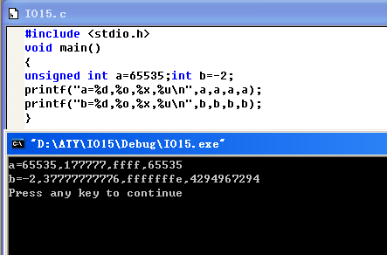
6

#include <stdio.h>
void main()
{
printf("%3s,%7.2s,%.4s,%-5.3s\n","CHINA","CHINA","CHINA","CHINA");
}
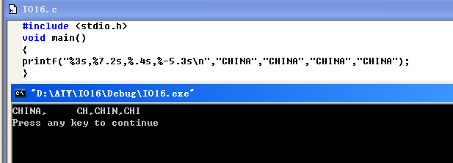
7

#include <stdio.h>
void main()
{ float x,y;
x=111111.111;
y=222222.222;
printf("%f",x+y);
}
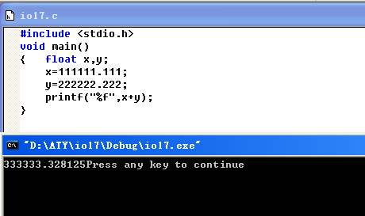
8

#include <stdio.h>
void main()
{double x,y;
x=1111111111111.111111111;
y=2222222222222.222222222;
printf("%f",x+y);
}
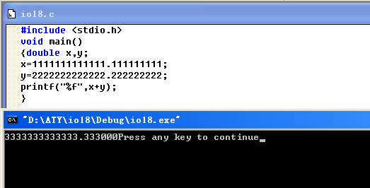
9

#include <stdio.h>
void main()
{
float f=123.456;
printf("%f%10f%10.2f%.2f%-10.2f\n",f,f,f,f,f);
}
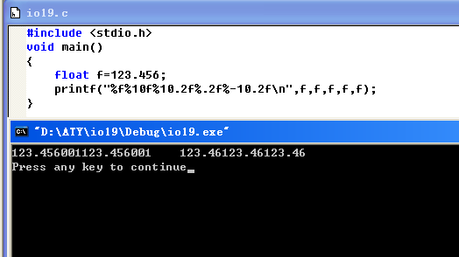
10

#include <stdio.h>
int main(void)
{int c;
for (;;)
{c=getchar();
if (c==EOF)
break;
if ((c>='a')&&(c<='z'))
c+='A'-'a';
putchar(c);
}
return 0;
}
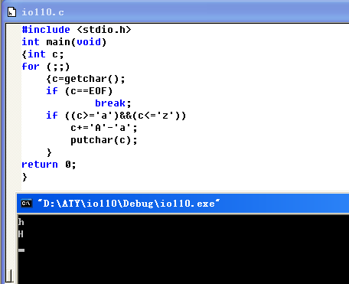
(1)After change:

#include <stdio.h>
int main(void)
{int c;
for (c=getchar();c!=EOF;c=getchar())
{/*c=getchar();
if (c==EOF)
break;*/
if ((c>='a')&&(c<='z'))
c+='A'-'a';
putchar(c);
}
return 0;
}
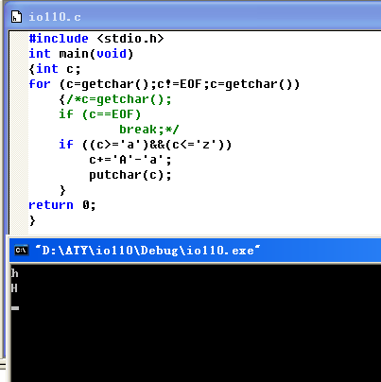
(2)
After change

#include <stdio.h>
int main(void)
{int c;
while ((c=getchar())!=EOF){
/*for (c=getchar();c!=EOF;c=getchar())
{c=getchar();
if (c==EOF)
break;*/
if ((c>='a')&&(c<='z'))
c+='A'-'a';
putchar(c);
}
return 0;
}
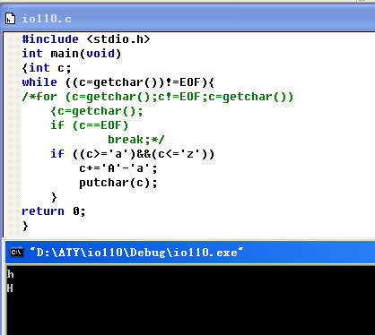
(3)

#include <stdio.h>
int main(void)
{int c;
c=getchar();
while(c!=EOF)
{
/*for (c=getchar();c!=EOF;c=getchar())
{c=getchar();
if (c==EOF)
break;*/
if ((c>='a')&&(c<='z'))
c+='A'-'a';
putchar(c);c=getchar();
}
return 0;
}
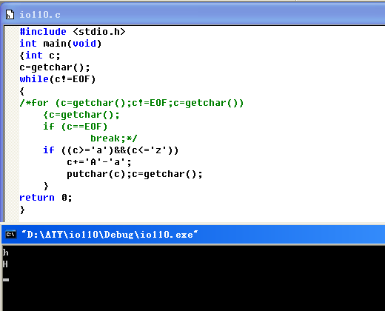
(4)

